ព្រះរាជាណាចក្រកម្ពុជា

ជាតិ​ សាសនា ព្រះមហាក្សត្រ

Institute of technology of Cambodia

Department of Information and communication Engineering



The lesson taking about Linked list function in c++

TP15 : Linked list

TP: Algorithm and Programming ll

Lecturer: BOU CHANNA

Student: VEN THON

ID: e20191250

Group: I3-GIC-C

Year: 2022-2023

Contents

Problem1: 3

Problem2: 4

Problem3: 6

Problem4: 8

Problem5: 11

# Problem1:

We want to storea list of all engineer students’IDat ITC(more students are added every year thus the list should be able to store unlimited numberofstudentIDs). Definea linked list data structure for this kind of problem.

Hint: Create a structure element and list. Data in element is ITC’s student ID.

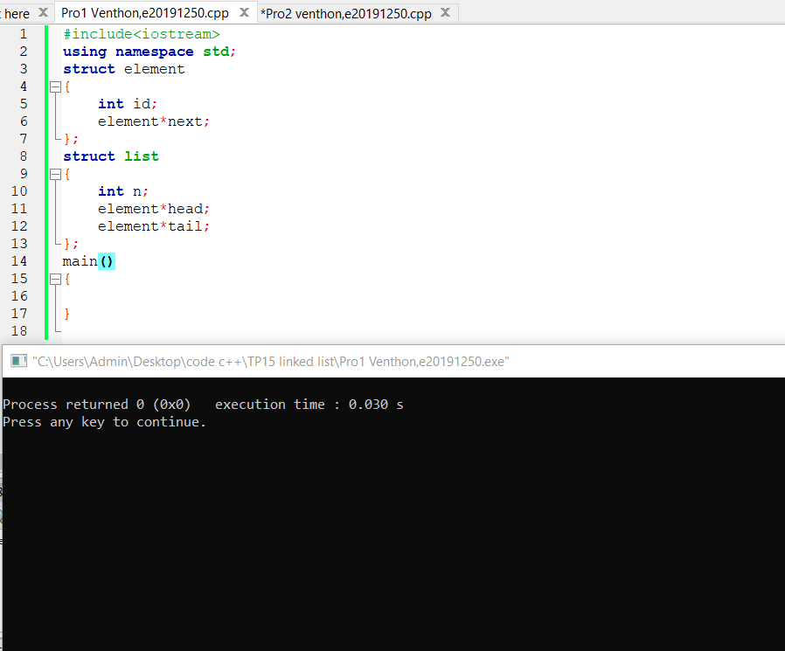

# Problem2:

In addition to problem #1, create 3 functions

:•a function to create an empty list,

•a function to add data to the list,

•a function to display all data in the list.

Then in main program, call these three functionsto test and see the result.Try to add 10 ID data of students into the list.

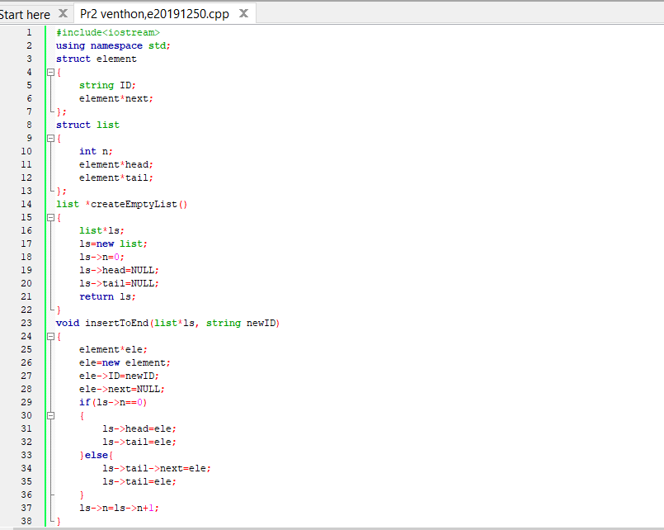

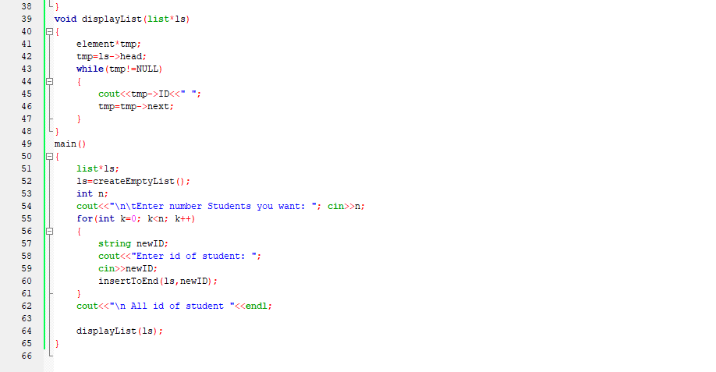

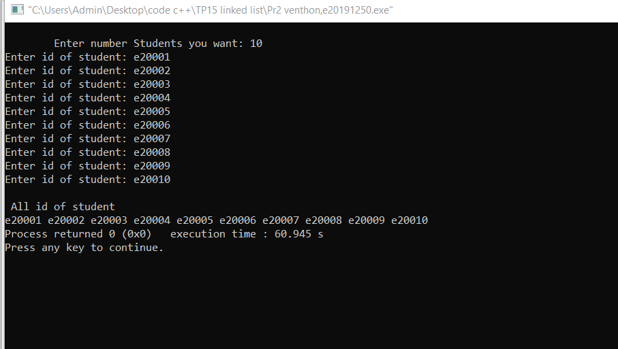

# Problem3:

Create a singly linked list that can store integer numbers. Create 4 functions i) create list, ii) add data to end of list, iii) add data to beginning of list, iv) display data in list. Then ...

•Create an empty list

•Add the number 7 to the beginning of the list

•Add 1 to the beginning of the list

•Display all numbers in the list17

•Add 0 to the end of the list

•Add the number 4 to the end of the list

•Display all numbers in the list

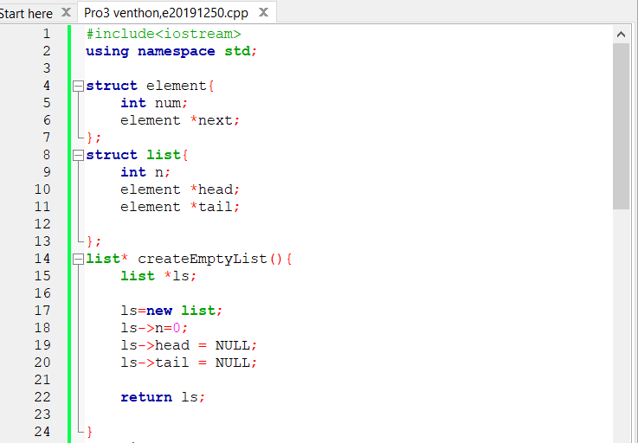

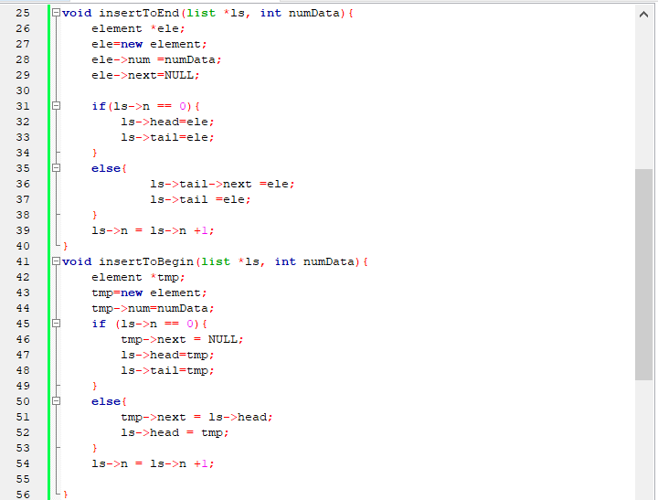

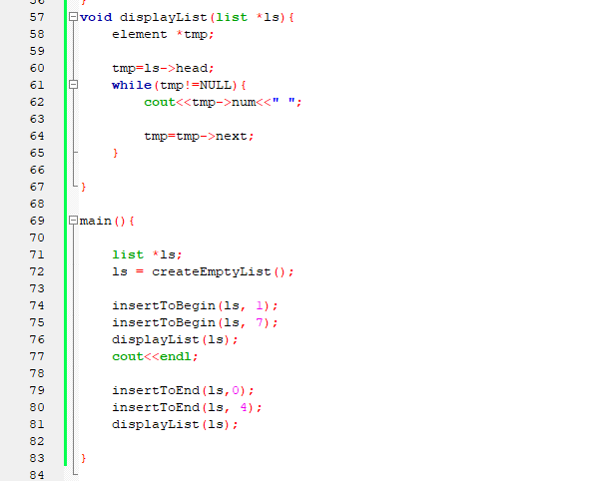

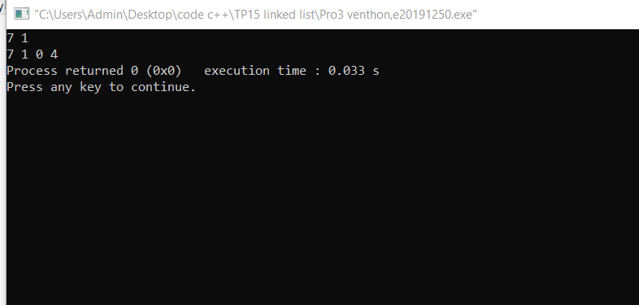

# Problem4:

Create a singly linked list for storing information of students. Each student has id, name, and average score. Then write a program to ....

•Create a function to ask for information (id, name, average score) for a student then add her/him to the list. The program does not add the student tothe list when the input id is already exist in the list.

•Create a function to display information of all students in the list.

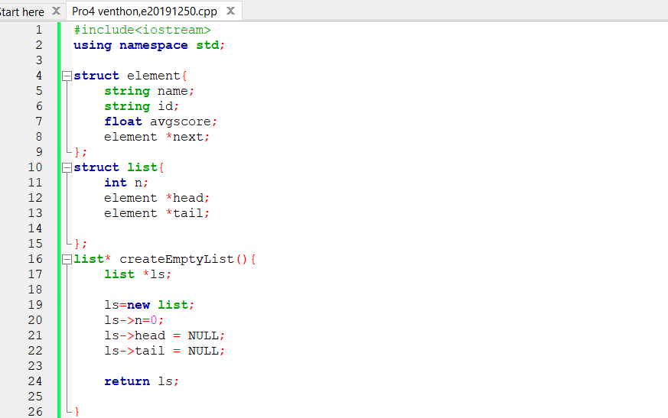

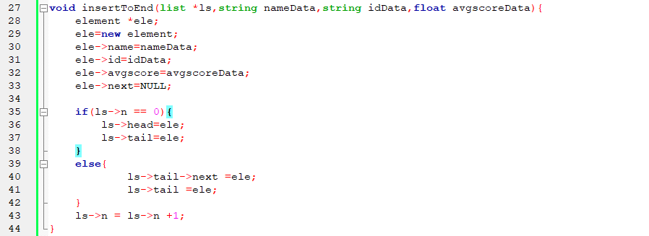

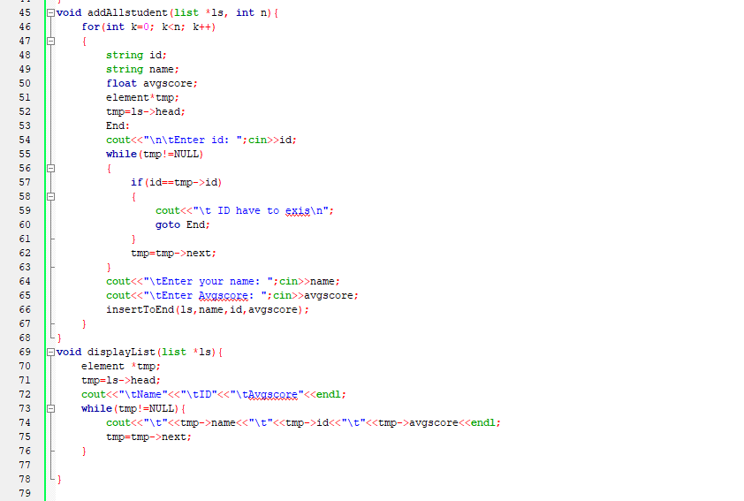

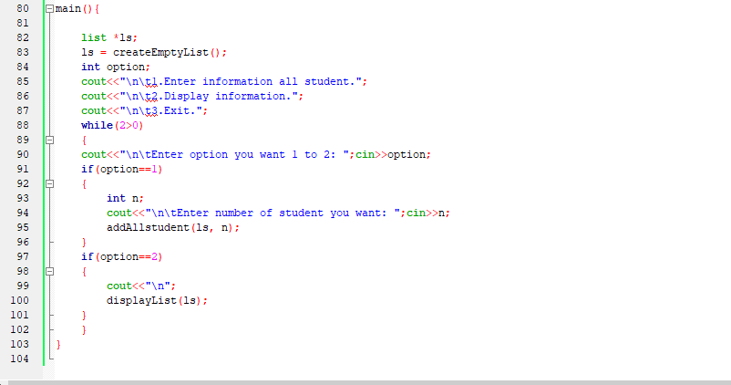

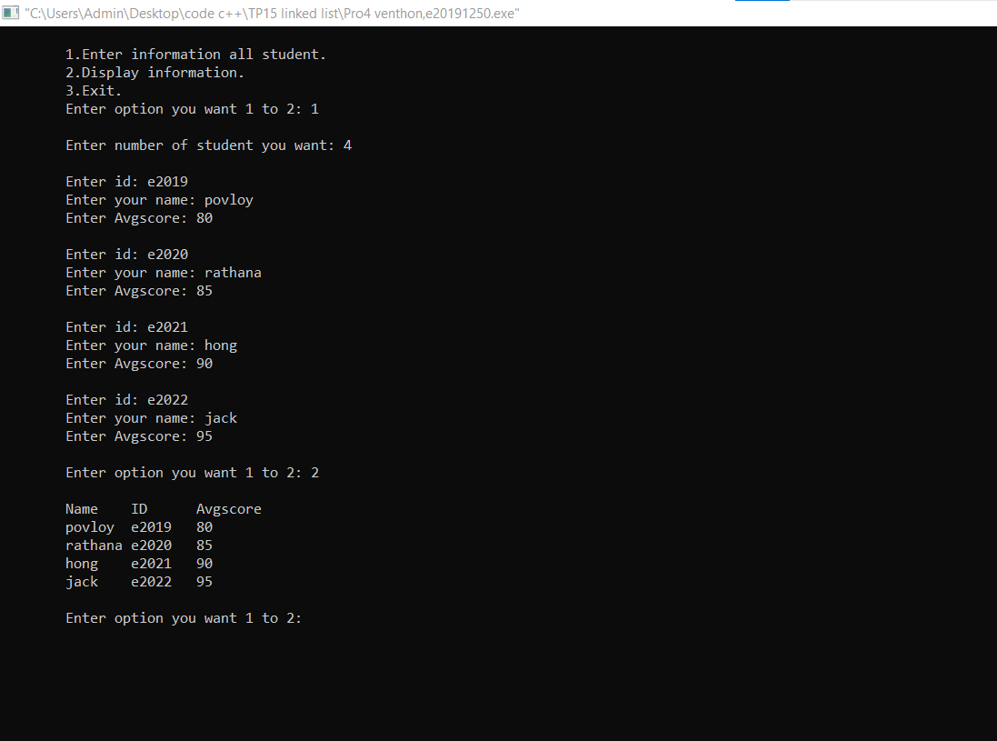

# Problem5:

Get many numbersfrom a user and store in a singly linked list.The program ask a user for a number then store in the list. When users input 0, stop asking user for more numbers. Display all data in the list. Find summation of all data in the list and show the result.

